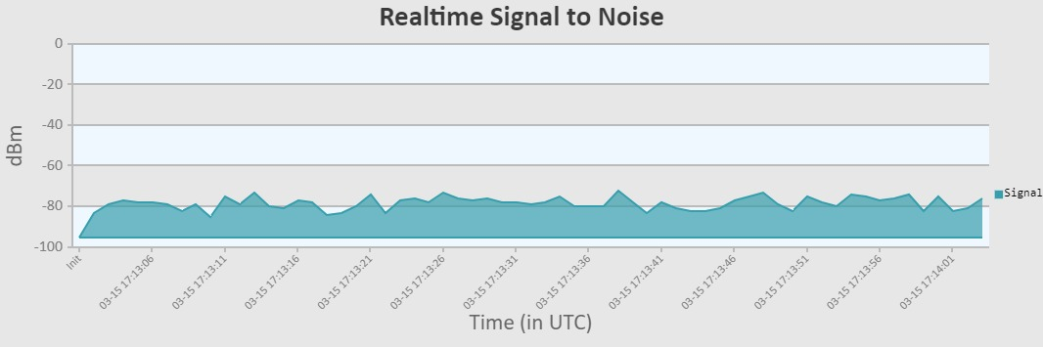
Downhill node MikroTik LDF2

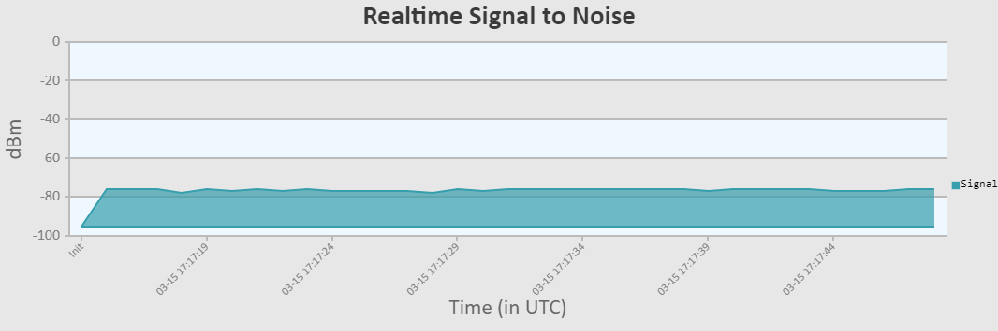
UpHill node MikroTik mANTBox

